**Lab 8: Identifying & Analyzing Network/Host Intrusion Detection System (NIDS/HIDS) Alerts**

**1 Load PCAP File to Security Onion for Analysis**

* 1. **Disable Firewall**

1. Launch the kali VM
2. With credentials provided log in
3. Launch a browser window
4. In the address bar type 203.0.113.1 to go to the pfSense firewall management login page, and log in with credentials provided

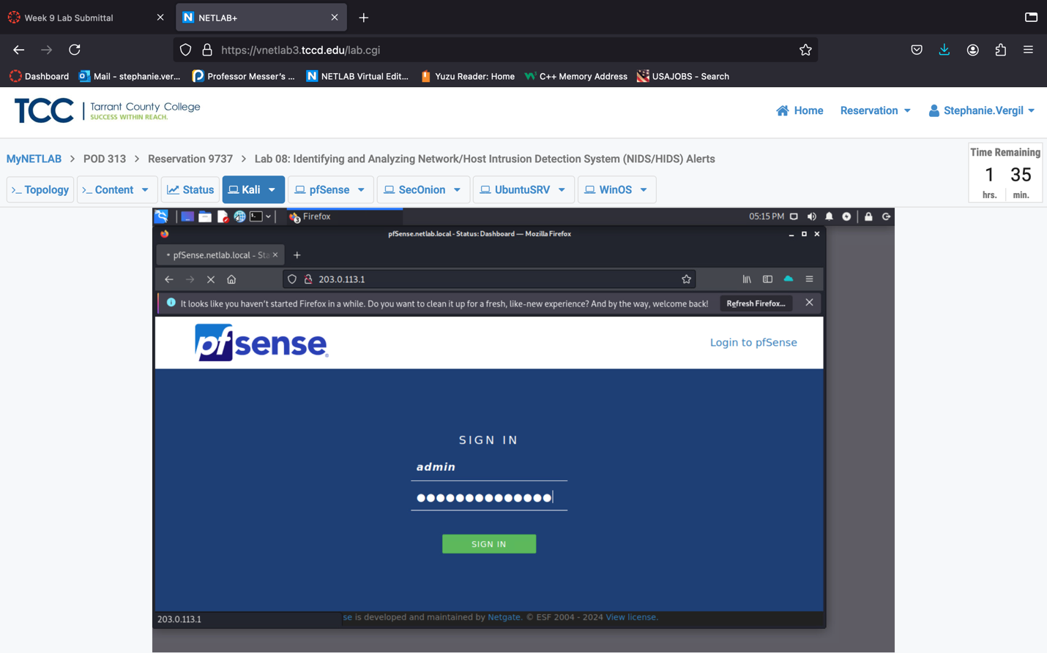

1. Once logged in, you will see the Status/Dashboard page; click the Firewall menu and select Rules.
2. Click the Disable button to disable the Block Internal network access rule.
3. Then click the Apply Changes button to confirm the action.

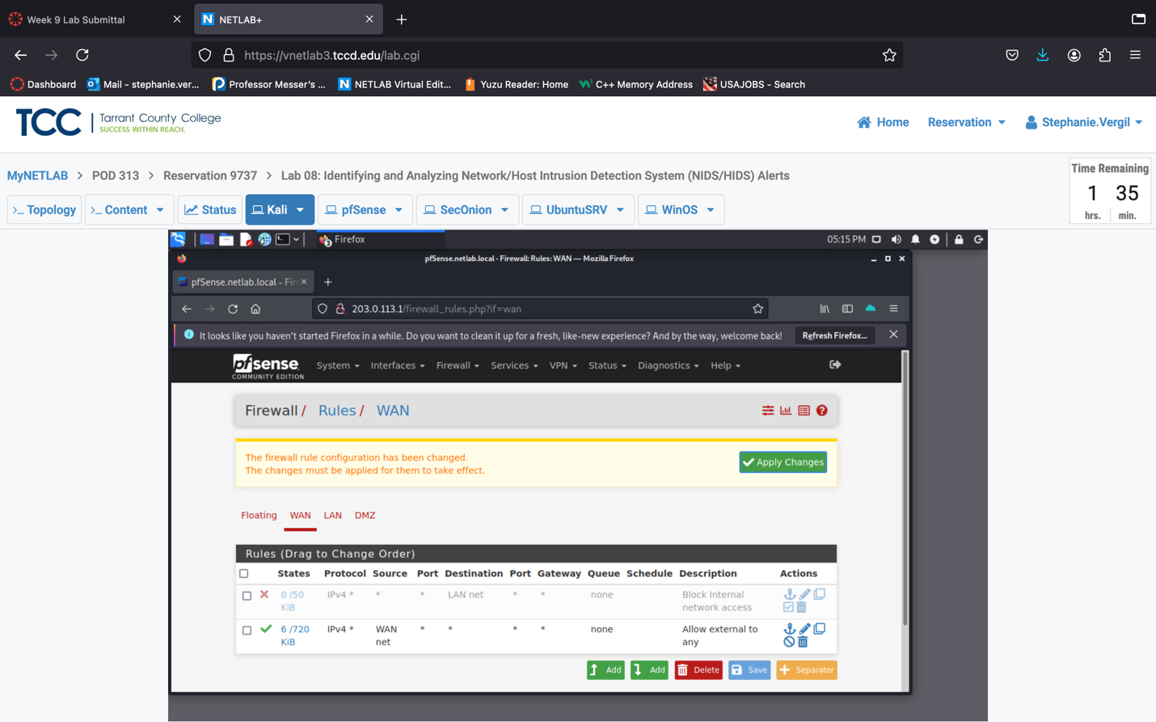

1. If you see a confirmation message, the change has been applied successfully. Minimize the browser window and proceed to the next section.

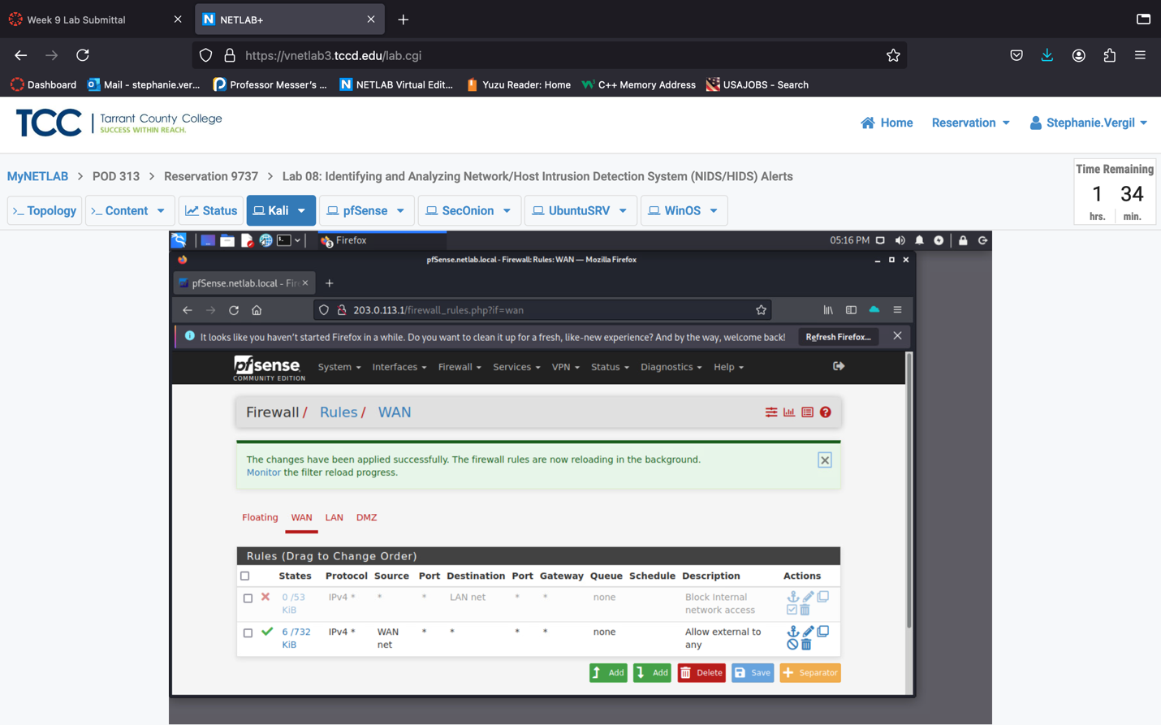

* 1. **Capture the Traffic for Analysis**

1. In the Kali VM, click Terminal to start a Terminal window.
2. Type the following command to start Wireshark and keep the process in the background: wireshark &
3. Wireshark should open, and on the Welcome page, you should see the wave line updating itself continuously on interface eth0.

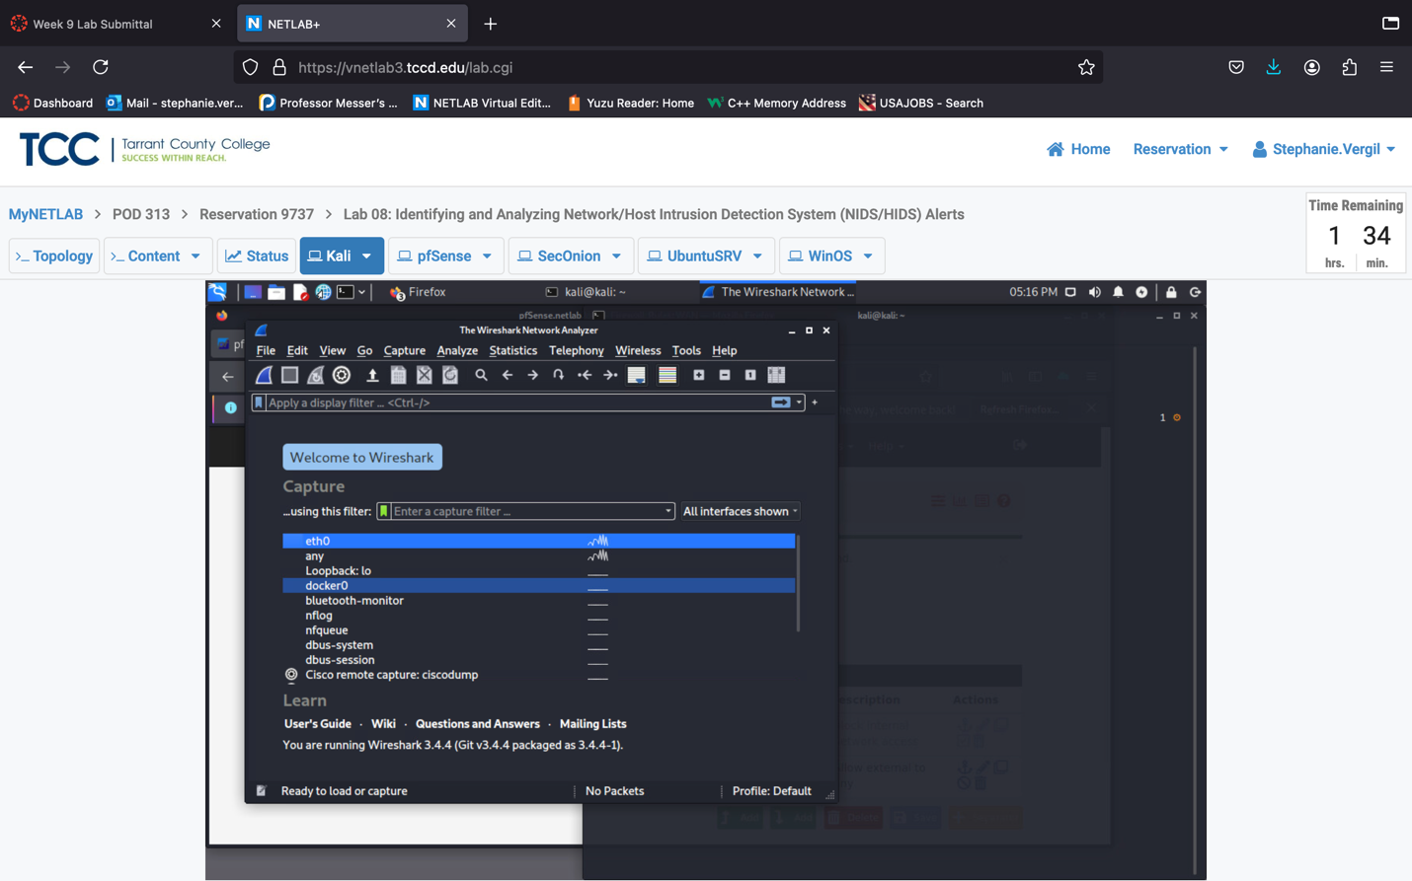

1. Rearrange the windows, so you can see both Wireshark and the Terminal on the screen.
2. In the Wireshark window, double-click on eth0 to start capturing traffic.
3. Keep the capture running and switch attention to the Terminal window. Type the following command to start an nmap scan: nmap -T5 203.0.113.1 192.168.0.0/24 172.16.1.0/28

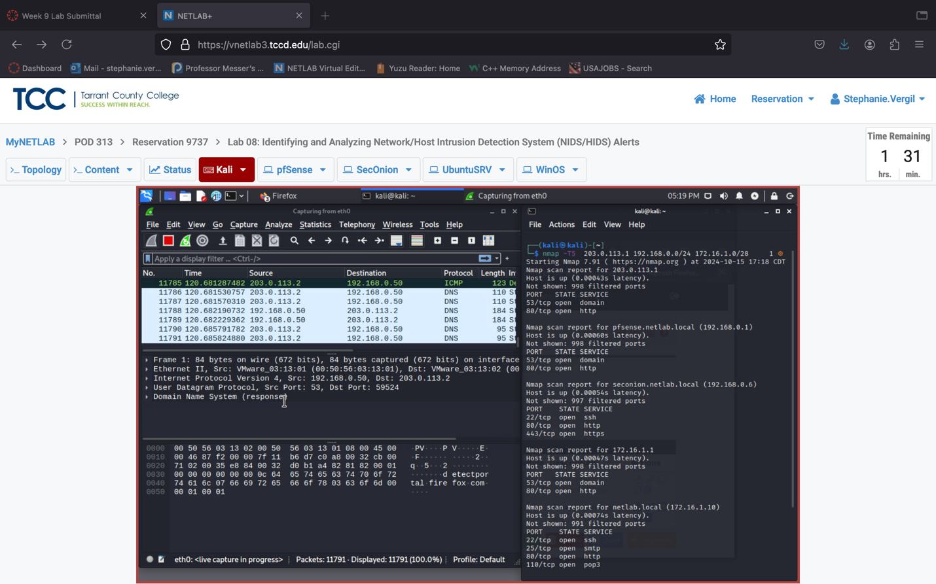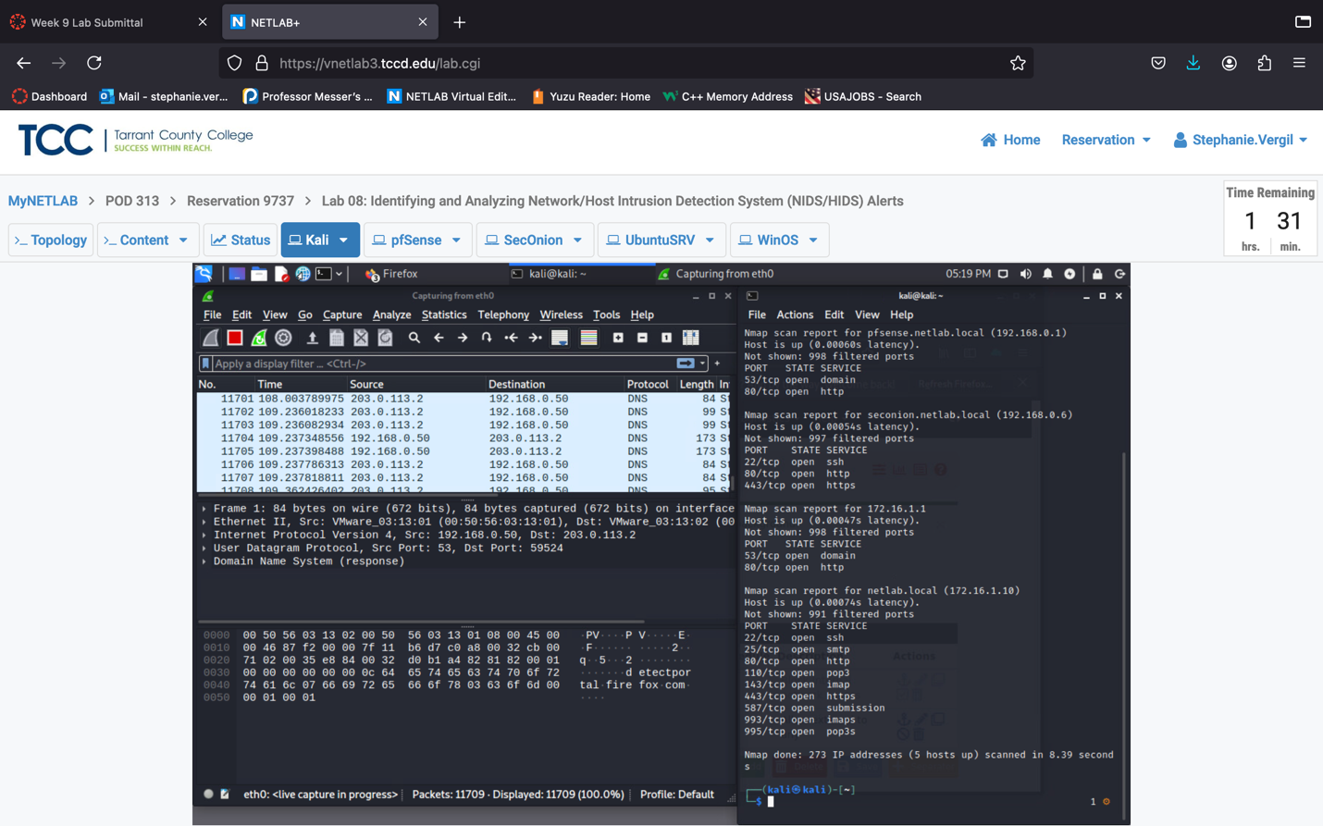

1. After the scan is finished, type the following command to target the 172.16.1.10 host to start an intensive scan: nmap -T4 -A -v 172.16.1.10

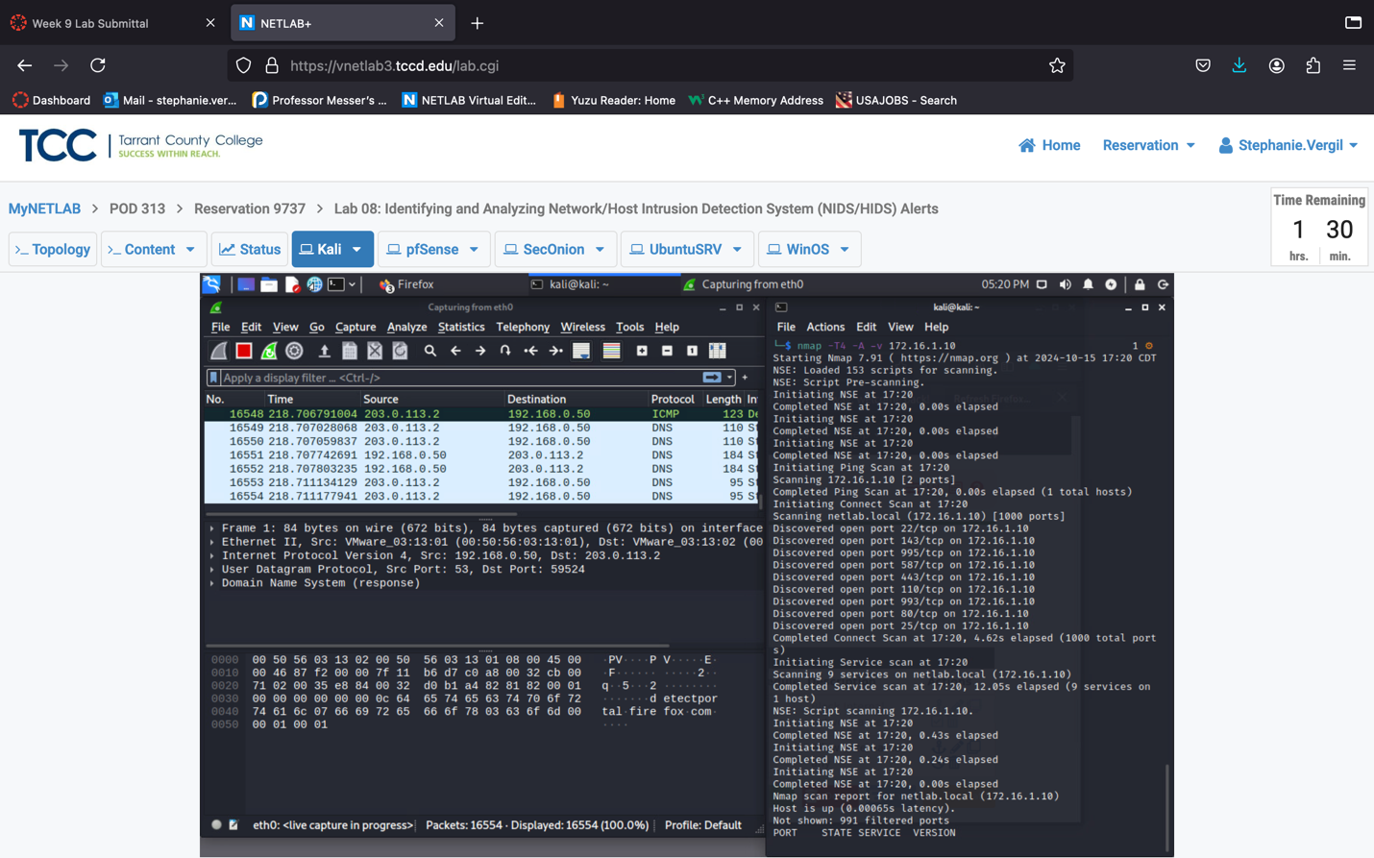

1. Once the scan is complete, it will say Nmap done… Stop the Wireshark capture by clicking the red square button.

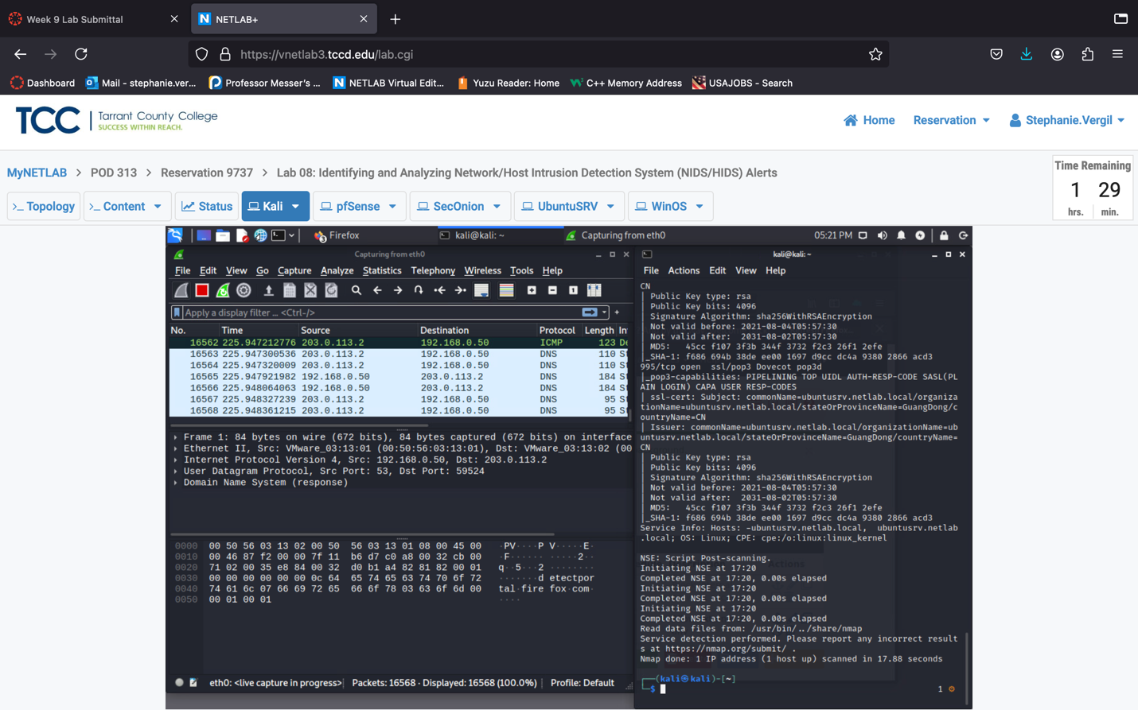

1. Click on File, then the Save As… option.
2. Type scan as the File name.
3. Then, click the dropdown box to the right side of Save as:, select the second option Wireshark/tcpdump/… - pcap.
4. Before you click the Save button, double-check the path to the file; we will save it to the /home/kali/Desktop folder. Then, click the Save button.

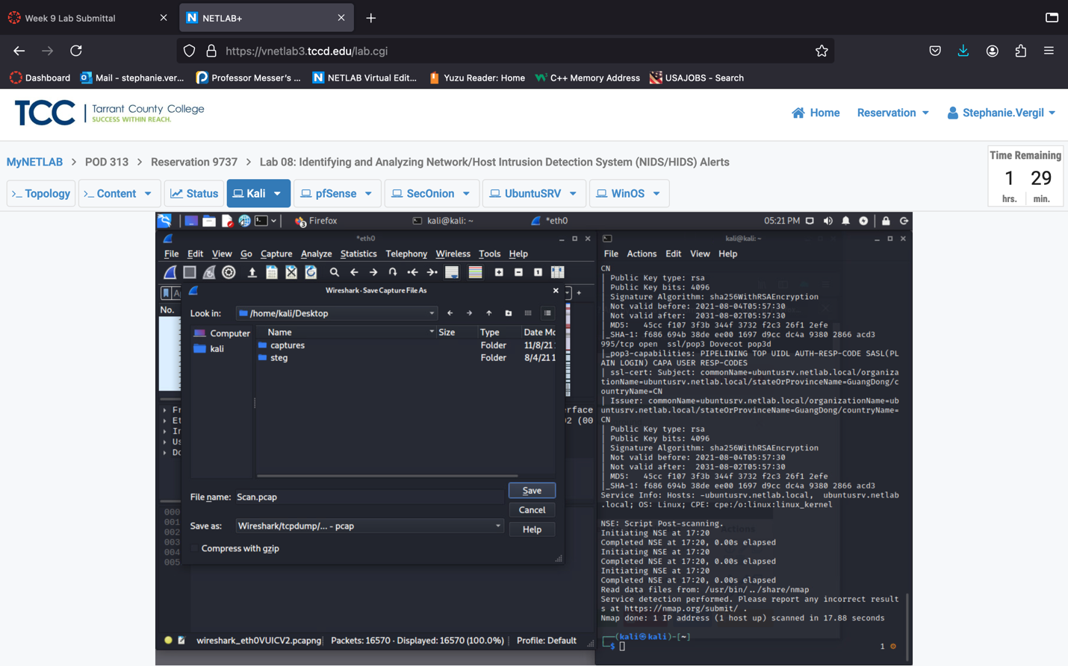

1. Leave the Wireshark window open and proceed to the next section.
   1. **Import the Traffic Capture**
2. Switch back to the Terminal window. Press Enter a couple of times to bring back the prompt. Then, we will start a simple HTTP server by using the following command; the server will run on default port 8000: python3 -m http.server

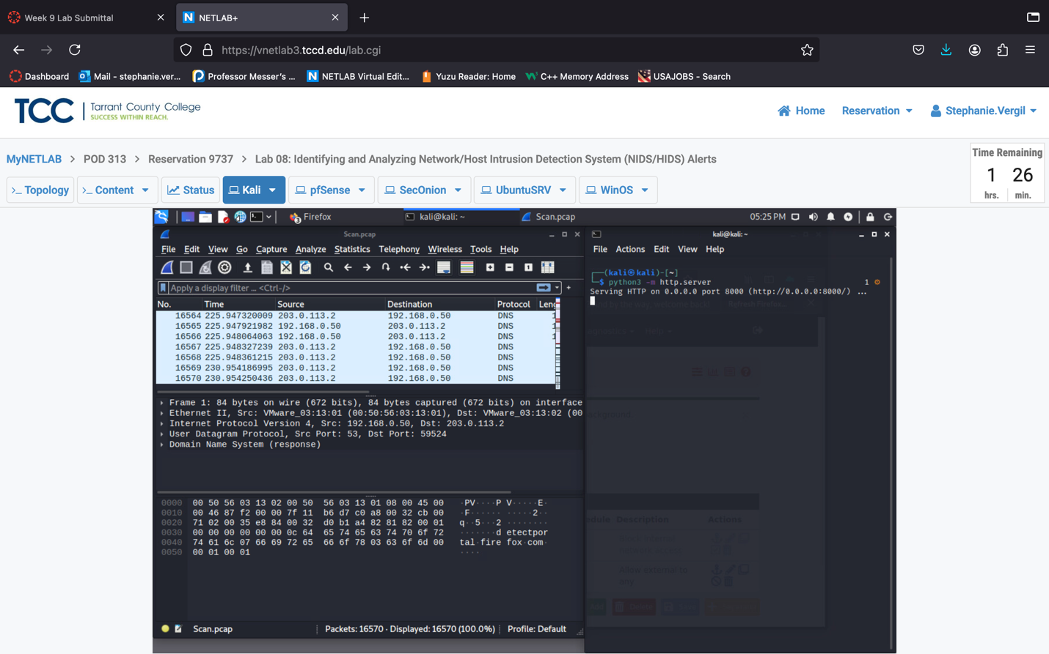

1. Launch the SecOnion VM.
2. Then click and drag up to unlock the screen for a login prompt.
3. Log in with credential provided
4. Once logged in, click Applications > Internet > Chromium Web Browser to start the browser.
5. In the address bar, type the address <http://203.0.113.2:8000>.

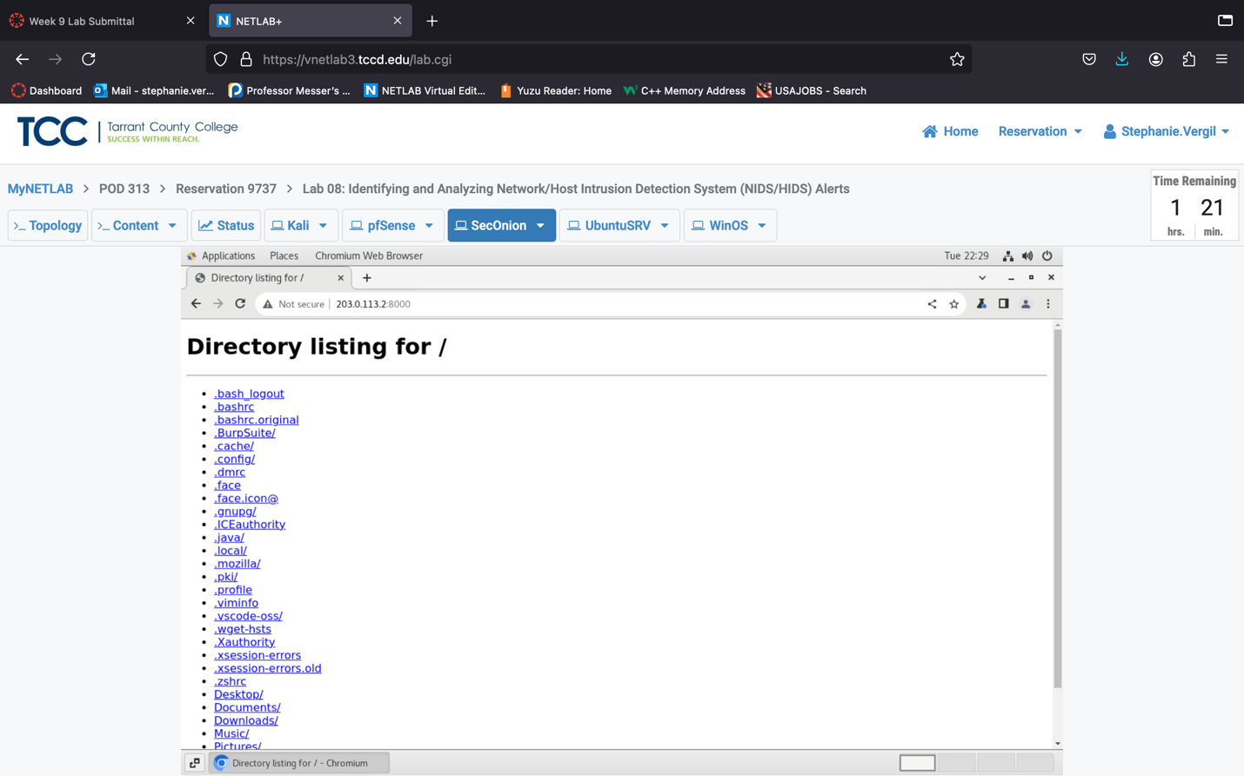

1. In the opened page, find and click on Desktop, then click on scan.pcap to download the file.

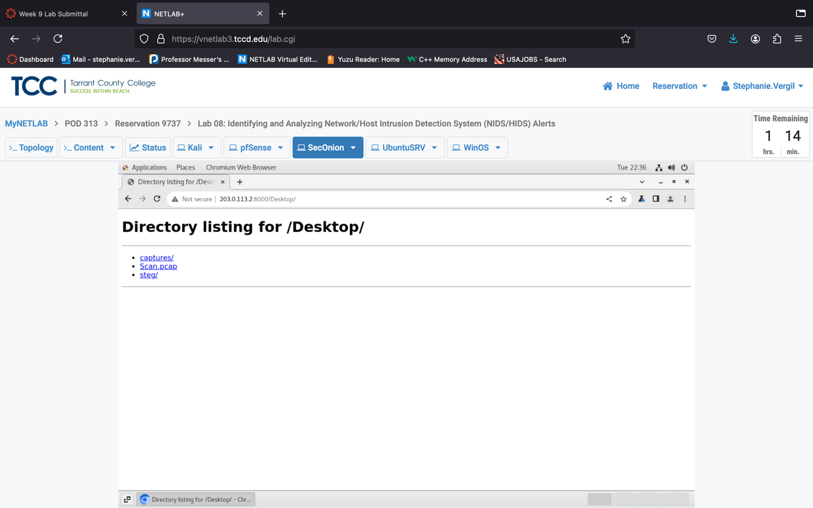

1. Once the file is downloaded close all the browser windows. If it prompts saying a download is in progress, do not close the window. Wait a little bit longer and try closing it again.
2. Now, click Applications again, and then System Tools, then click Terminal to start a terminal window.
3. We will first check the status of the services required for this lab. In the Terminal window, type: sudo so-status. Enter credentials when prompt. The command will run and check all services. The result should show OK on all of them. If not, wait a couple of minutes and check again. The status of OK is critical to this lab; you will want to wait until all of them indicate OK.

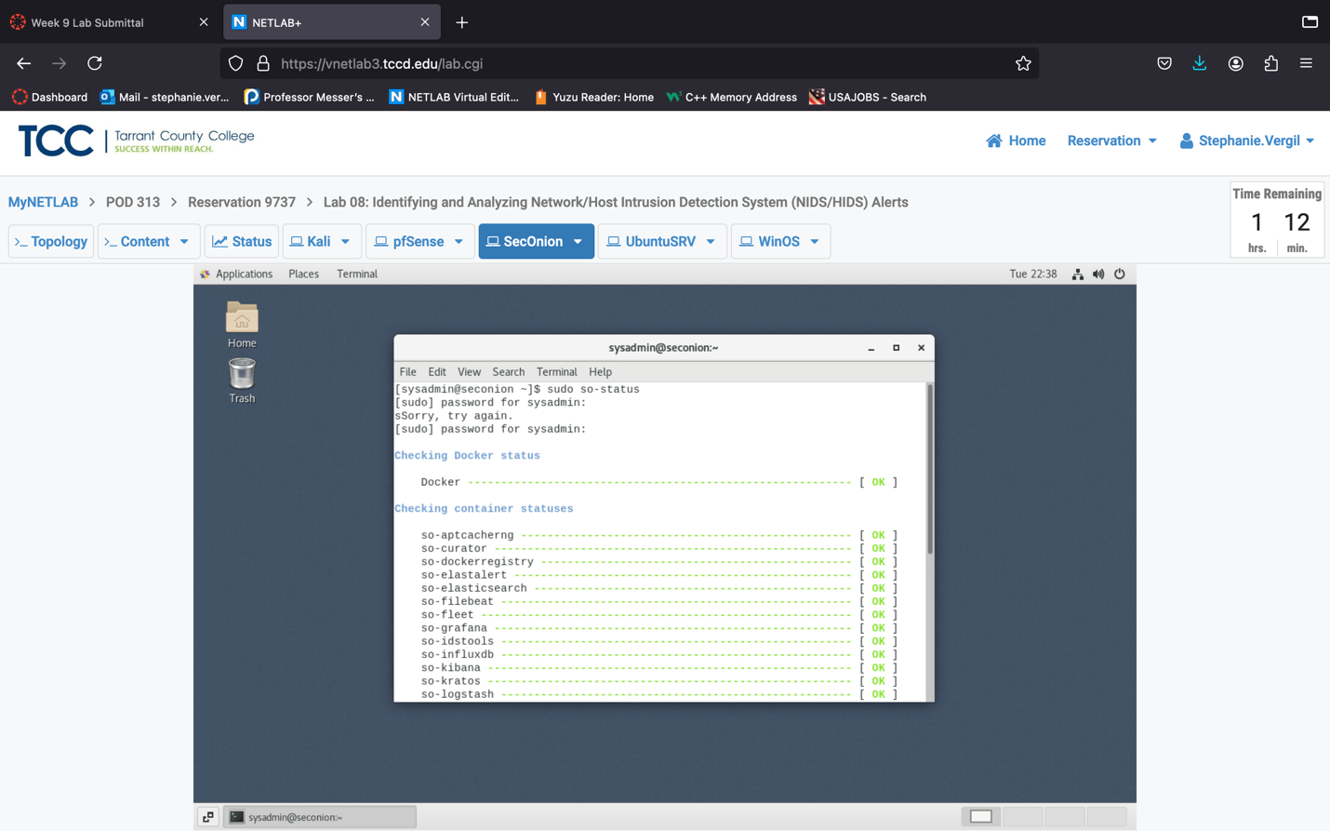

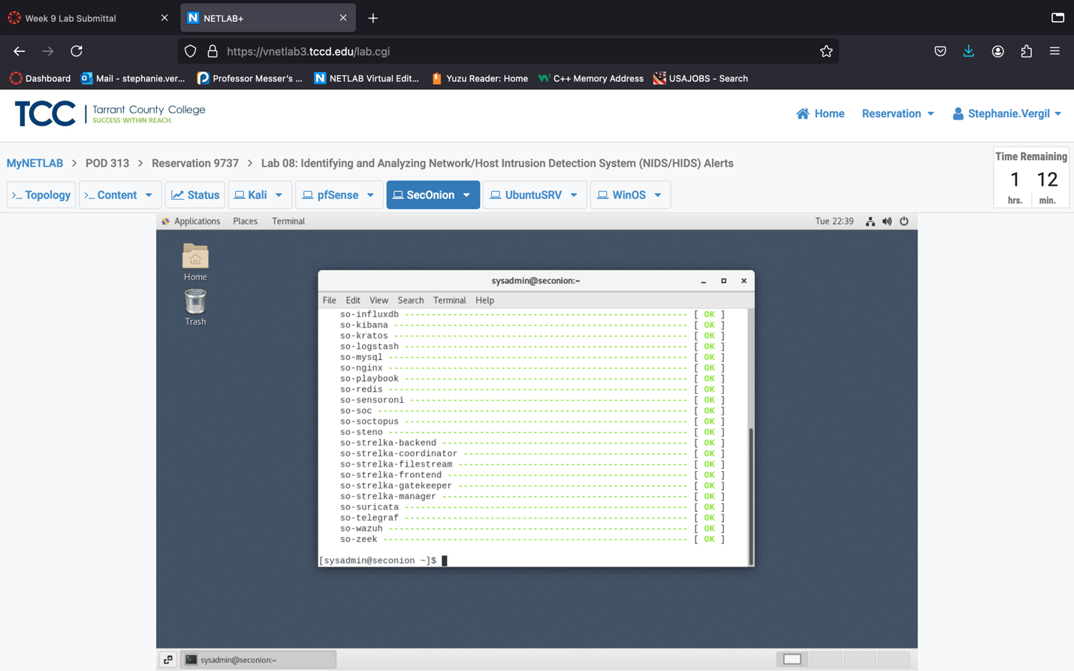

1. Next, we can import the pcap file to SecOnion. Type the following command: sudo so-import-pcap ~/Downloads/scan.pcap

When the import completes,. We’ll wait a little bit here.

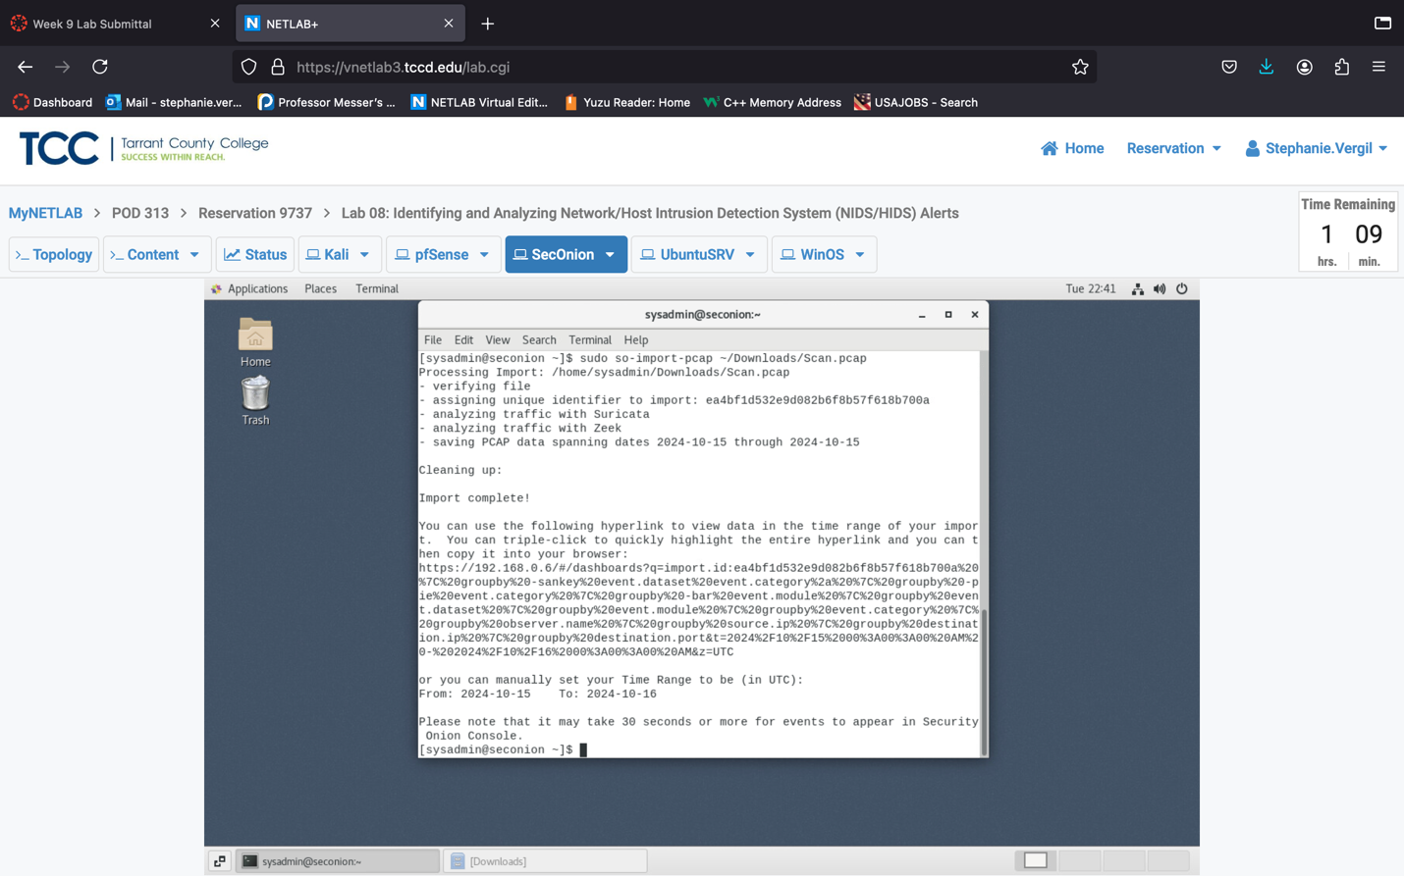

1. Leave the Terminal window open and proceed to the next section.
2. **Analyze the Data and File a Case**
3. Switch to the Kali VM. In the Terminal, we should still have the server running. Press Ctrl + C to stop the process.

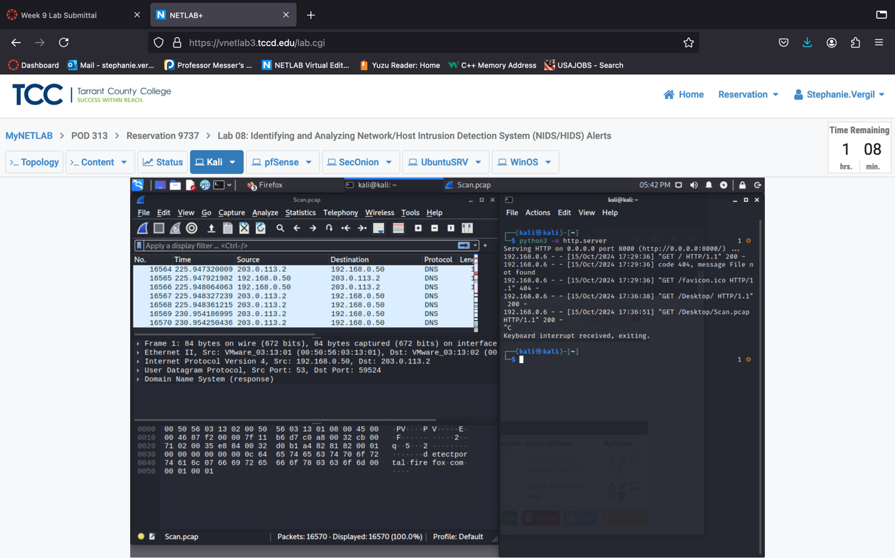

1. Switch back to the browser window, click the + to start a new tab.
2. Type 192.168.0.6 and press Enter to visit the SecurityOnion main page.
3. If the warning page shows up, click the Advanced… button. Then, scroll down and click Accept the Risk and Continue.

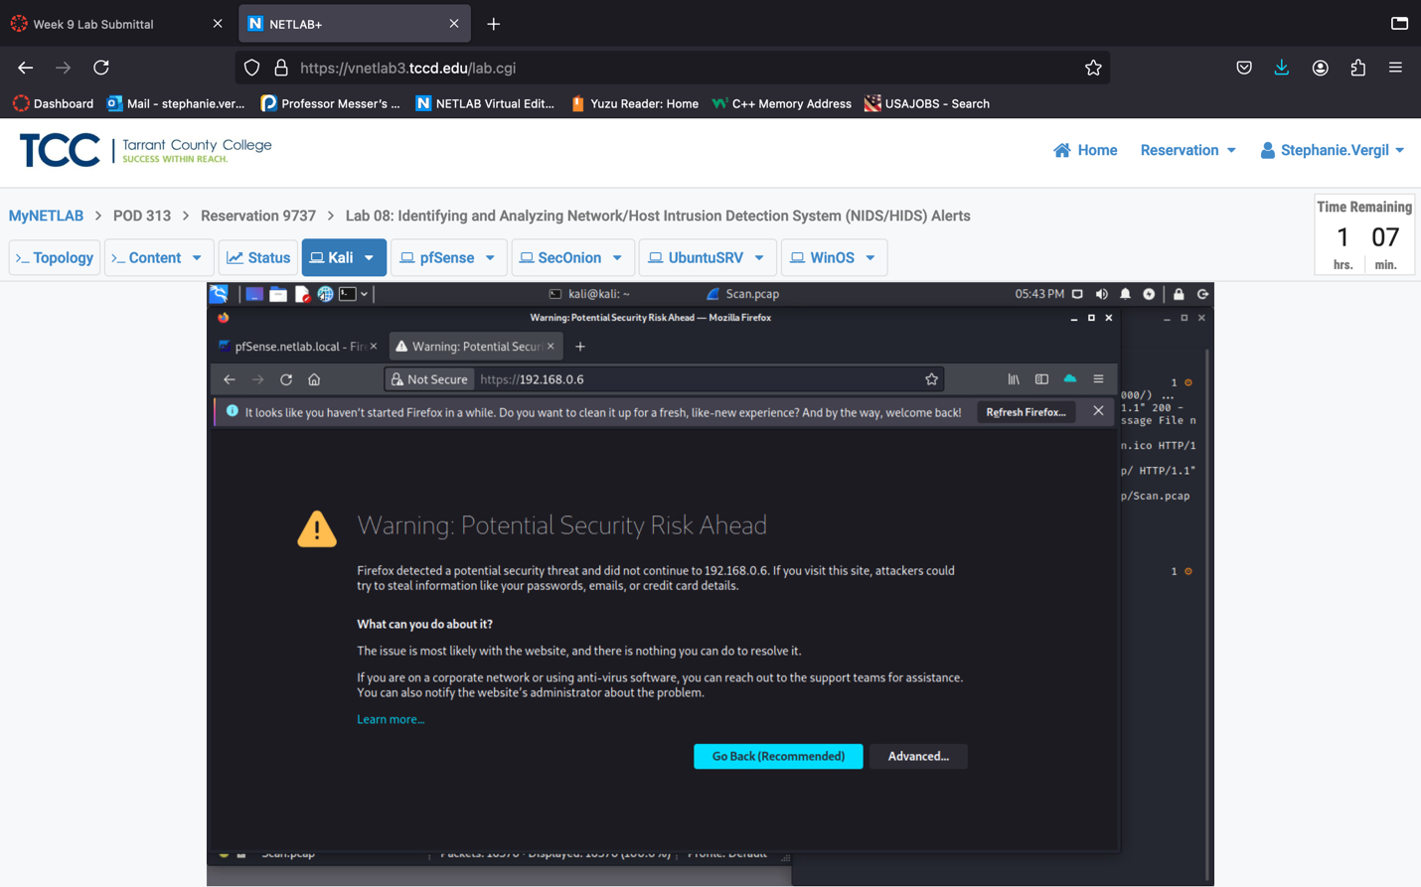

1. On the Login page log in with credential provided.

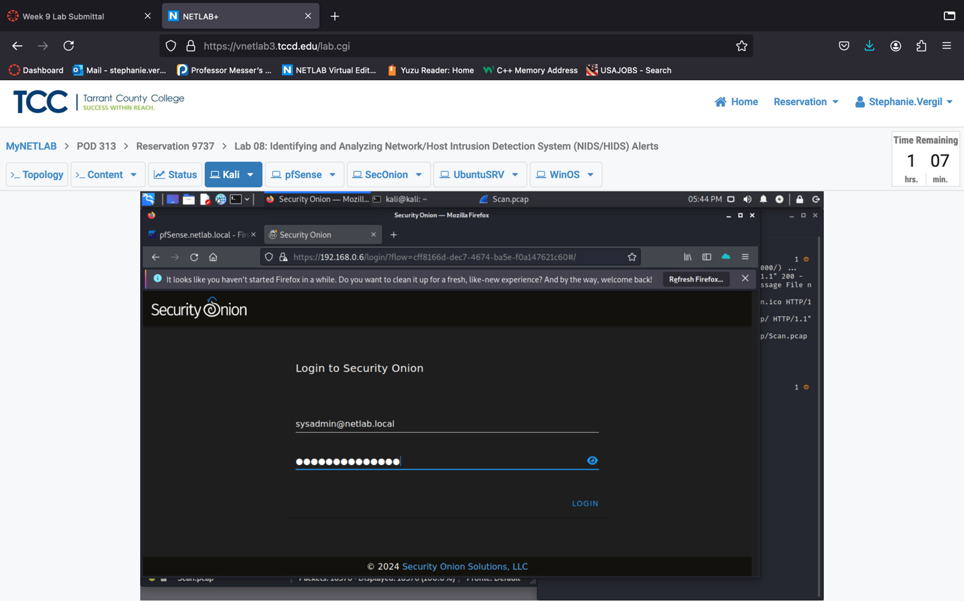

1. On the Overview page, click the menu button at the top-left corner. Then, click on Alerts.
2. If the import is finished, you will see the top of the screen like below, indicating there were 134 alerts found; they were grouped by name and module, and you can change the time of the findings.

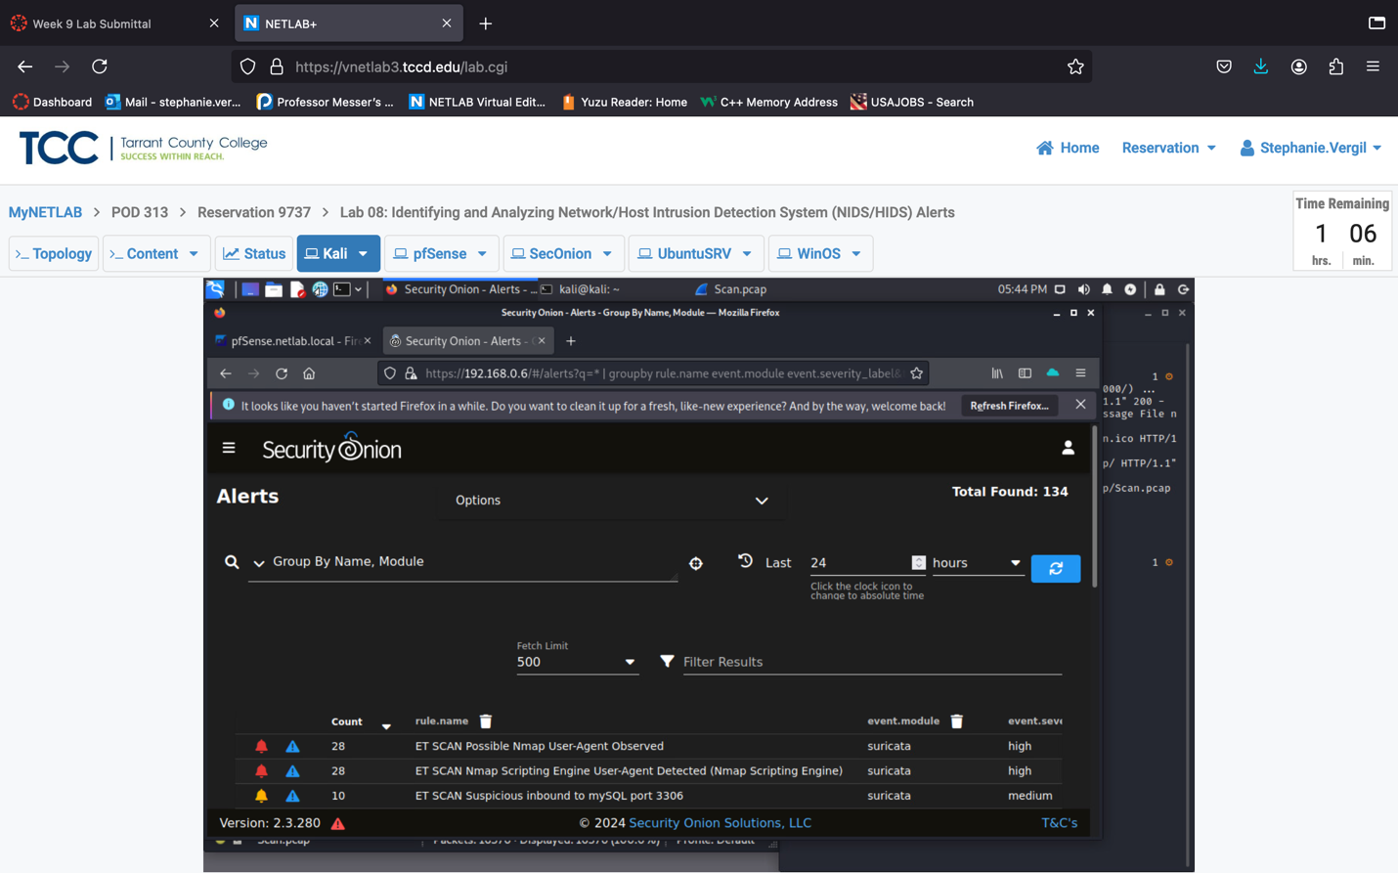

1. At the bottom half of the screen, there’s a list with colored bell icons showing the severity of alerts. Keep in mind that clicking the bell will acknowledge the alert, not open its details. The blue triangle with an exclamation mark is the "Escalate" button, which raises the alert and allows it to be added to a case. We’ll discuss this more in the next section. The third column shows the number of alerts grouped by the rule name (in the fourth column) and module (in the fifth column). The last column shows the alert’s severity. You might need to hide the navigation panel on the left to view all the columns.

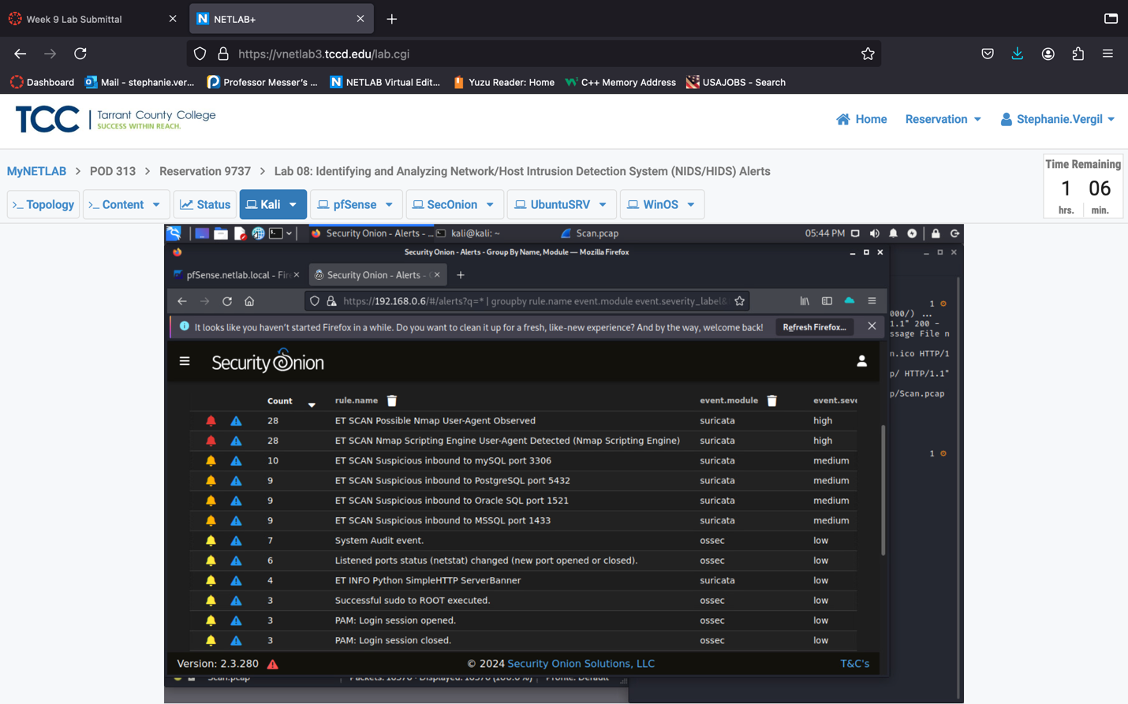

1. Leave the SecurityOnion window open and proceed to the next section.
2. **Add a Case, Investigate, and Close the Case**
   1. 1. **Escalate an Alert to Add a Case**
3. With the SecurityOnion still opened, let’s examine the alerts and analyze a few of them. First, left-click on the ET SCAN Possible Nmap User-Agent Observed rule name, then select the Drilldown option.

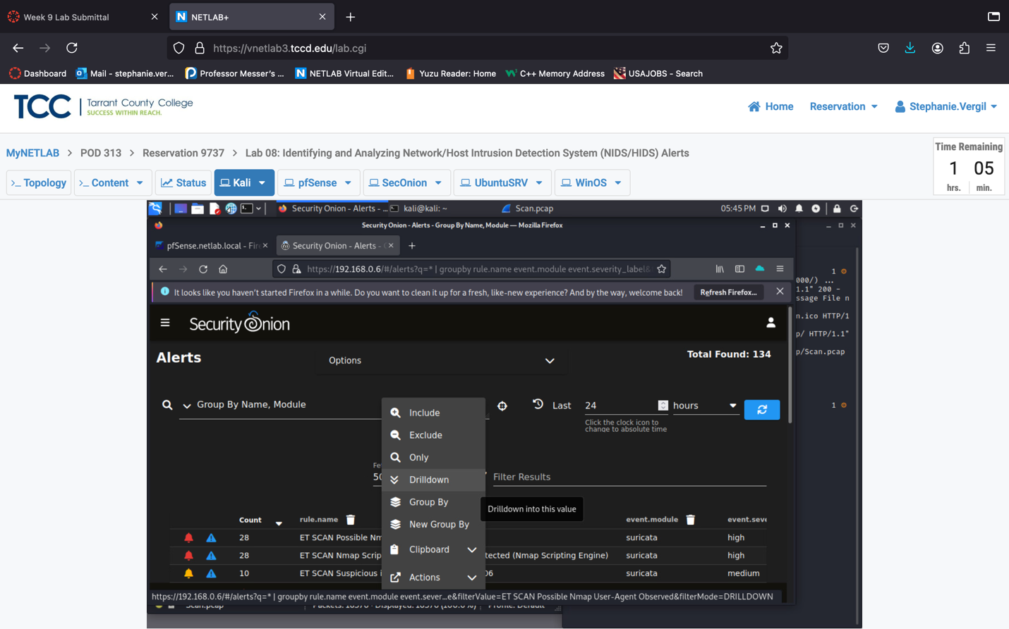

1. The view will be changed, and you should see something like below, click the arrow in front of the first entry.
2. Detailed information about this alert will show up. Scroll down to learn more about it for example the destination.ip, destination.port, source.ip, source.port, network.data.decoded, rule.rule, etc.

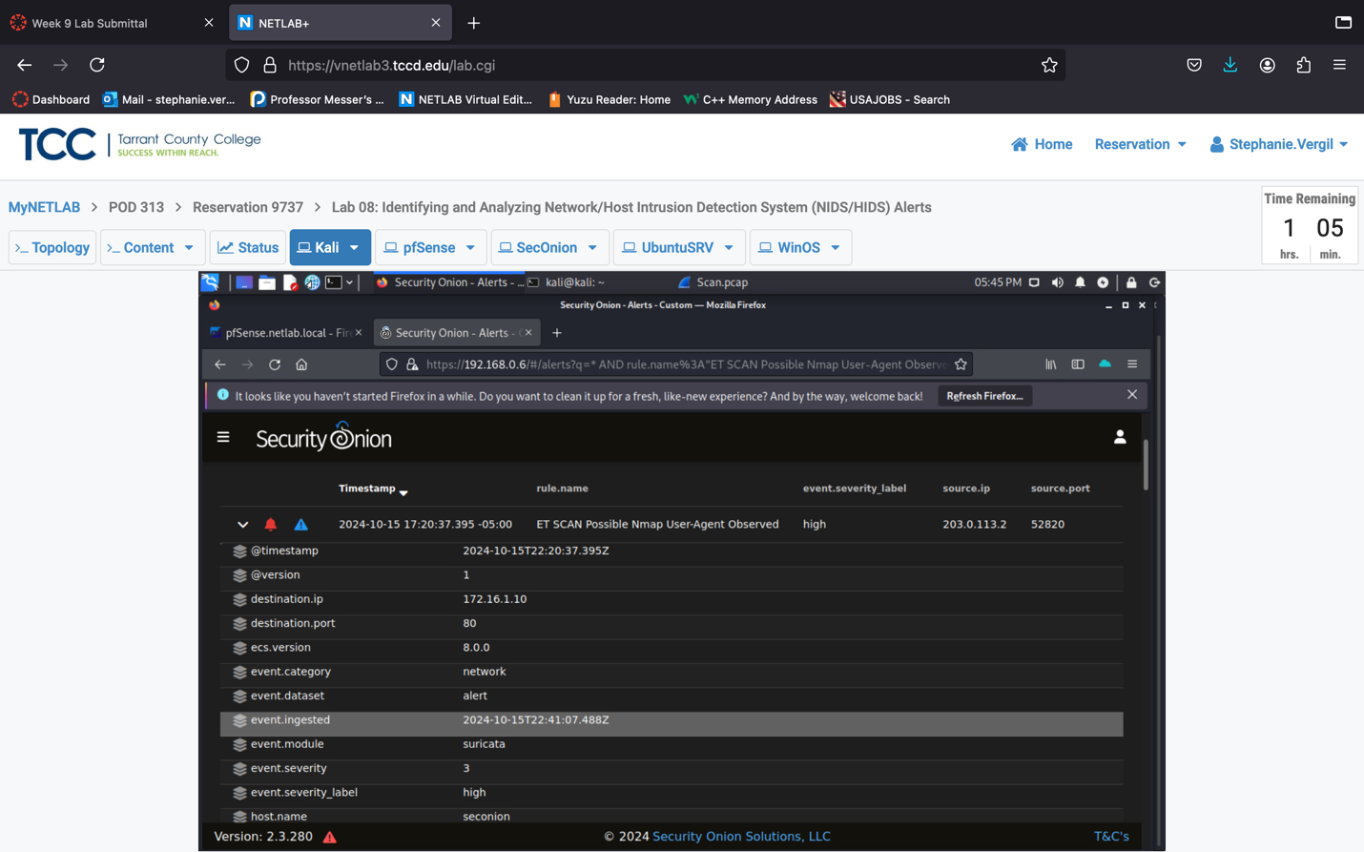

1. Once again, left-click on the ET SCAN Possible Nmap User-Agent Observed rule name, then select Actions, then PCAP to show the captured packet for this alert.

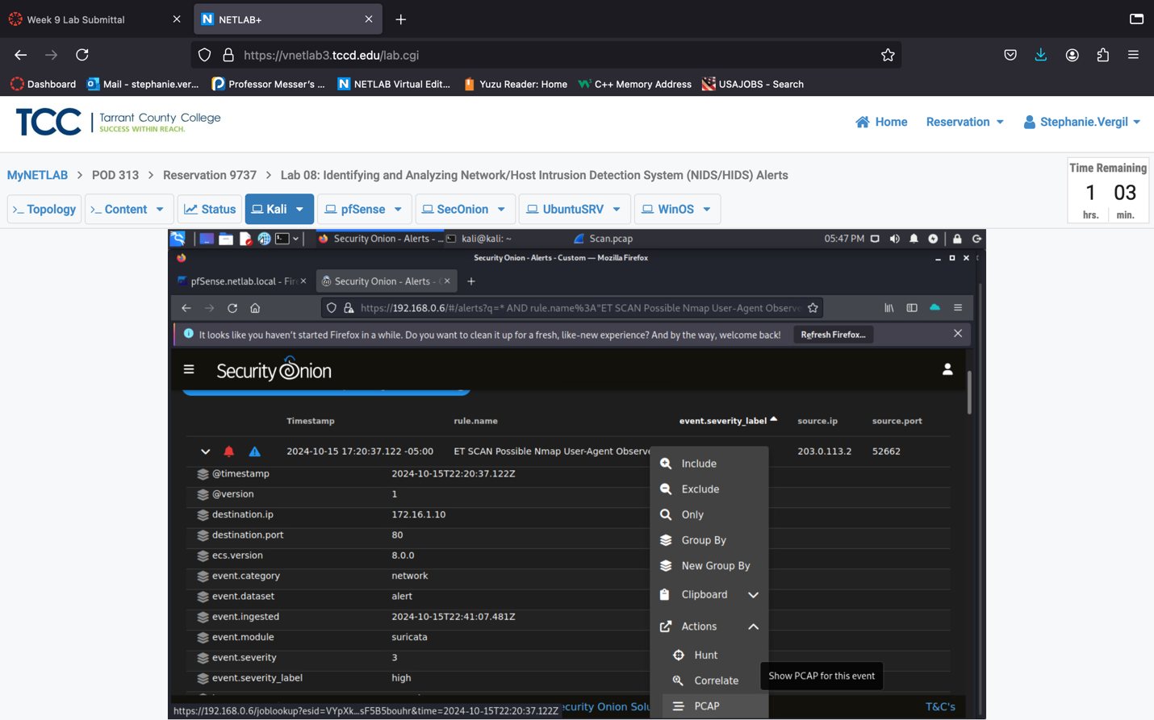

1. We will be brought to the PCAP view, which shows the stream of this traffic, starting from the three-way handshake.

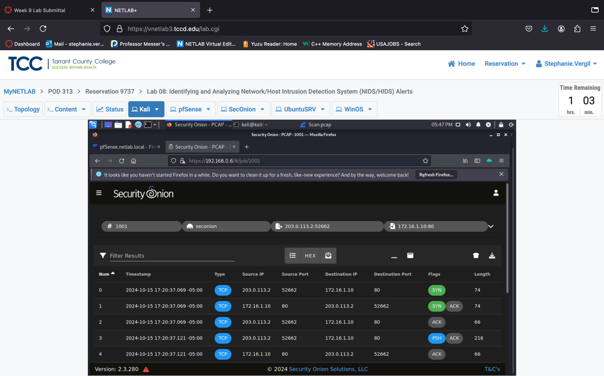

1. Switch on and off the toggles to see different views of the captured traffic.
2. If you are familiar with the Follow Stream on Wireshark, you may find this view also exists in thenSecurity Onion PCAP module (click the first list toggle, then the HEX toggle).

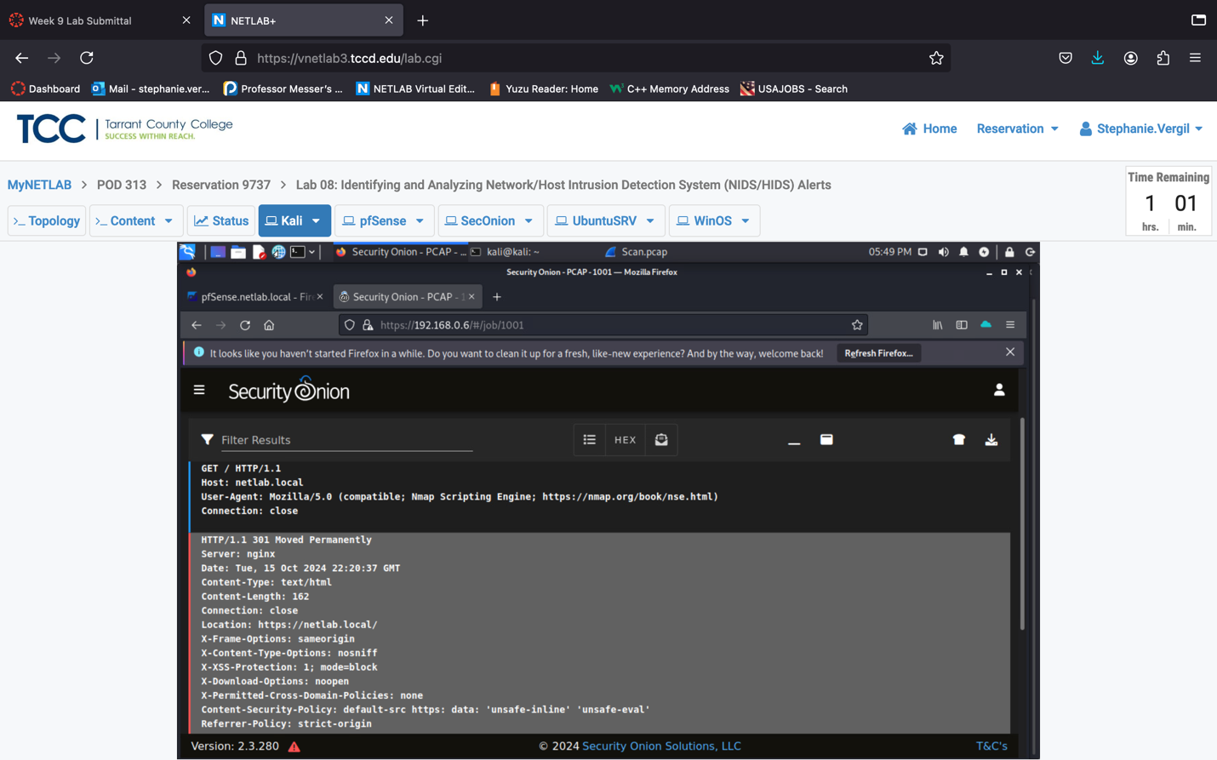

1. Next, let’s go back by clicking the Back button in the browser.
2. Once the page is loaded, left-click on the source.ip of 203.0.113.2 and select the Only option. This will filter the alerts to only show the ones that originated from the source IP of 203.0.113.2, which is our Kali VM.

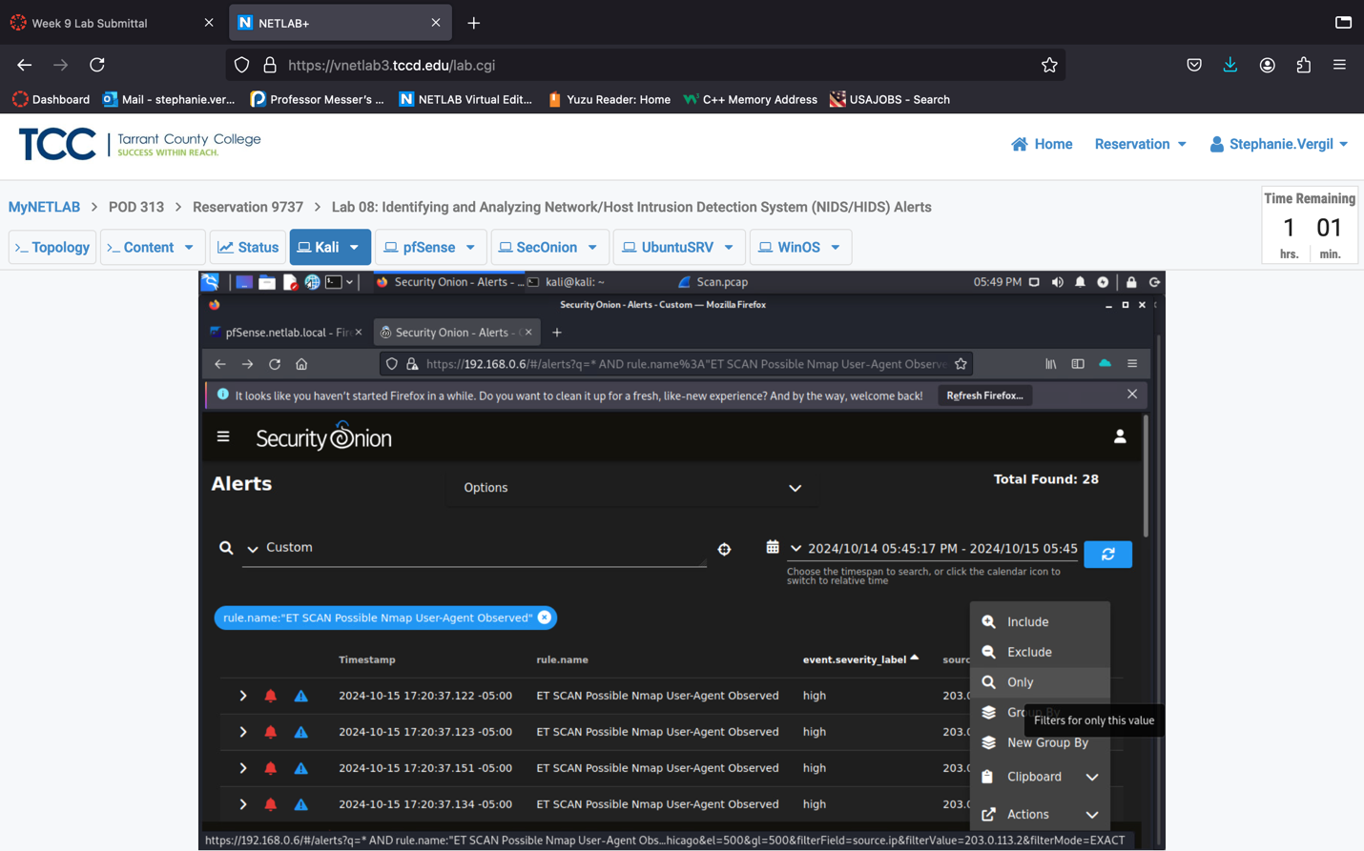

1. Now, we can see that 98 of the alerts are filtered, and they were all originated from the Kali VM. Feel free to scroll up and down to see the severity levels of those alerts.

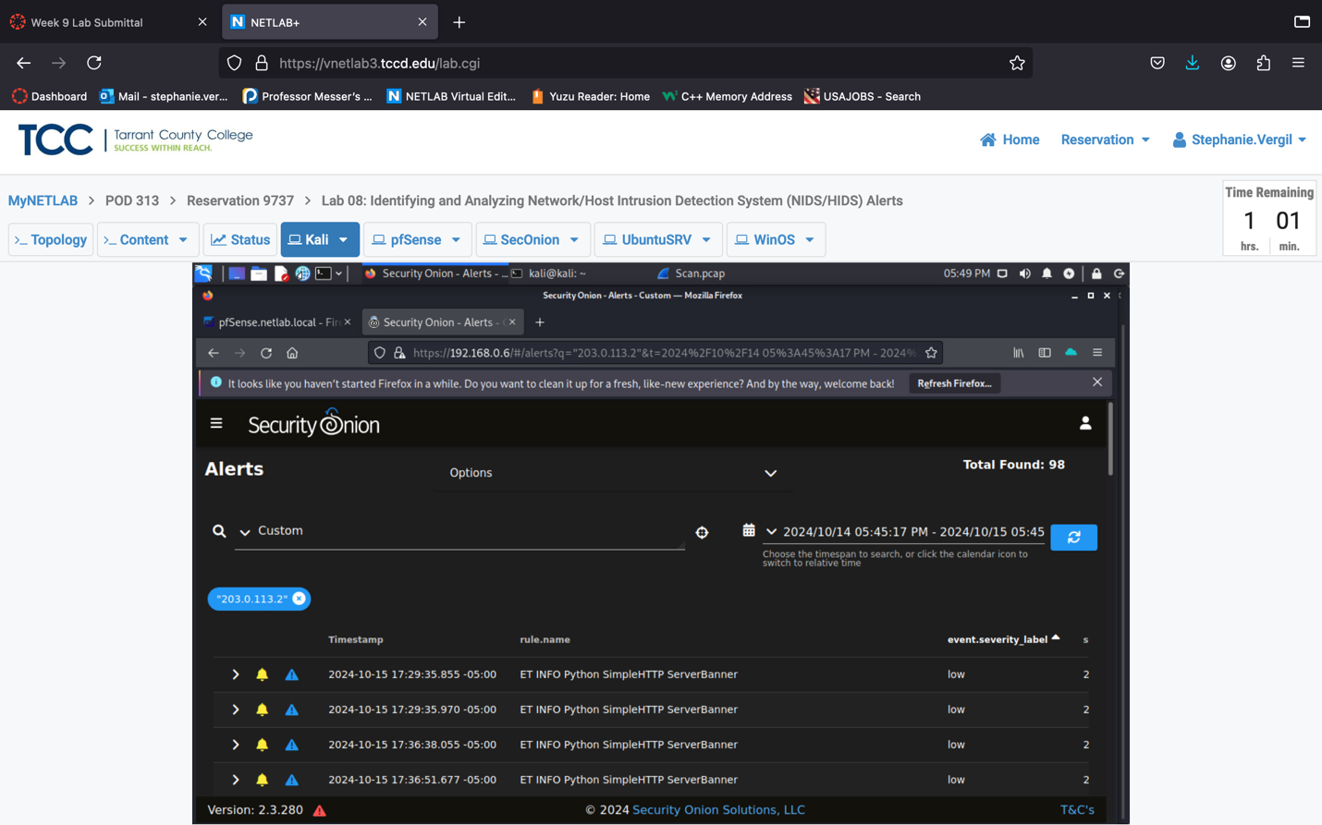

1. Click on the Timestamp column header to list the results in chronological order. Now we see that the first alert is a medium severity with suspicious inbound activity. Left-click on the name and select Actions, then select Hunt.

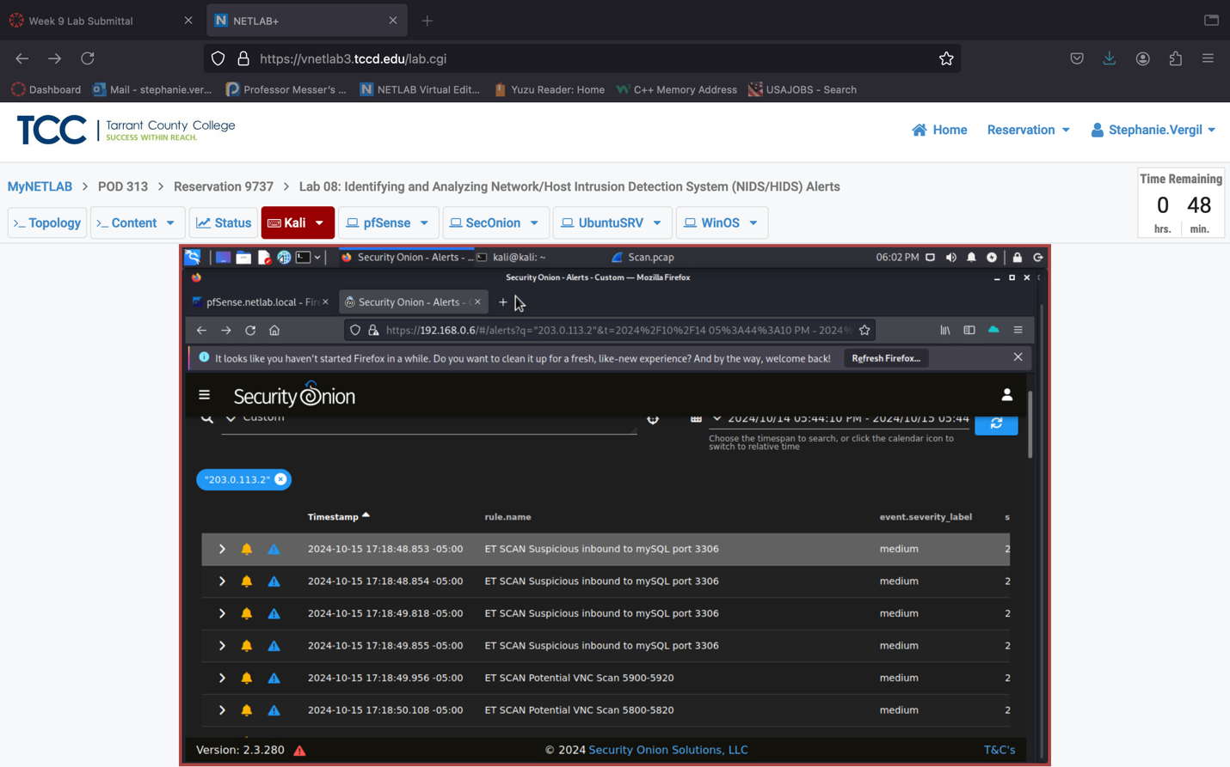

1. You will see the Hunt tool page as shown below. On this page, it will bring more details about this alert most of the time. Hunt is used to find similar events, track down malicious files, and observe malicious behaviors.

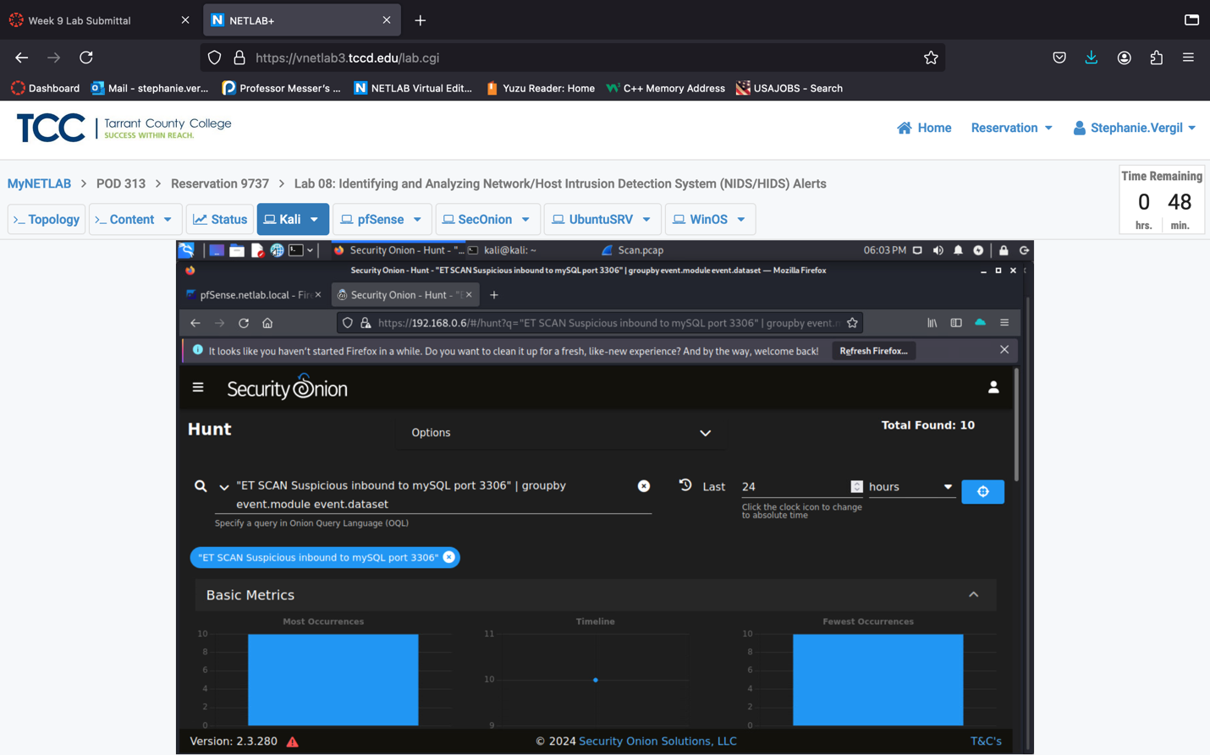

1. Click the browser Back button again. Let’s say that we need to escalate and create a case for the suspicious inbound activity and nmap scan alert. Click on the first blue triangle and then select + Escalate to new case.
2. Once added, it’s going to prompt and say Escalated alert and removed from view.

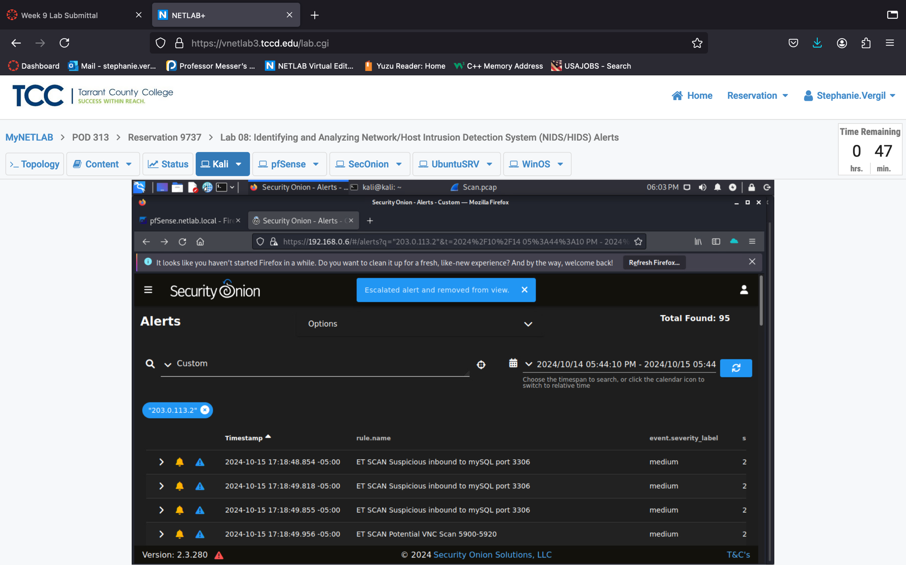



1. Leave the window open to continue with the next task.
   1. **Add Observable and Tasks for Further Investigation**
2. View the Cases dashboard by navigating to the top-left corner, clicking the Menu button, then selecting the Cases menu option
3. You should see the case list with the newly added cases.

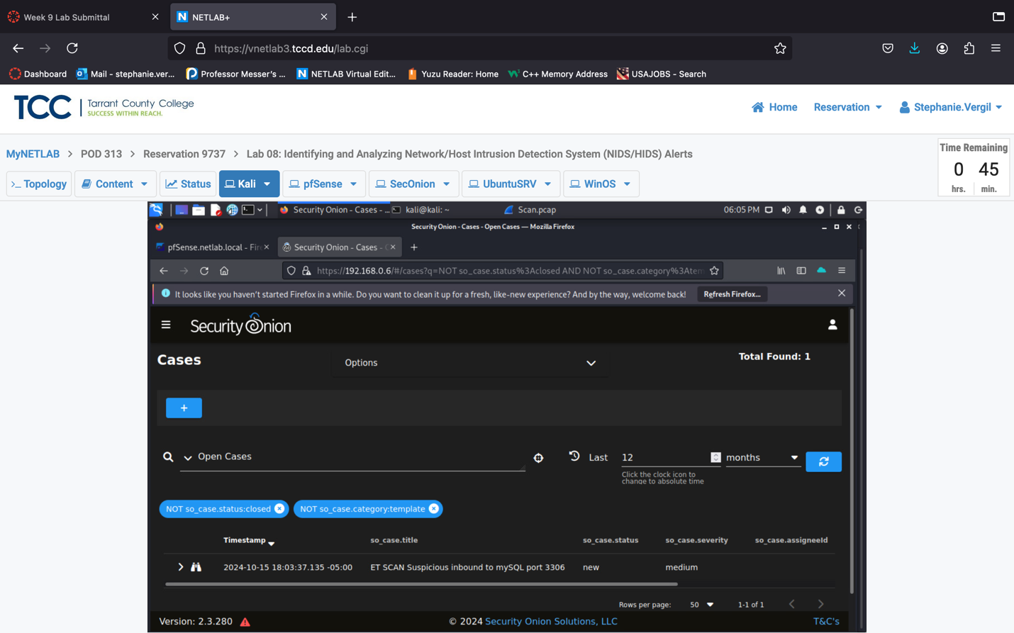

1. Click on the right arrow next to the first case entry to view additional details related to the case and Review the information.

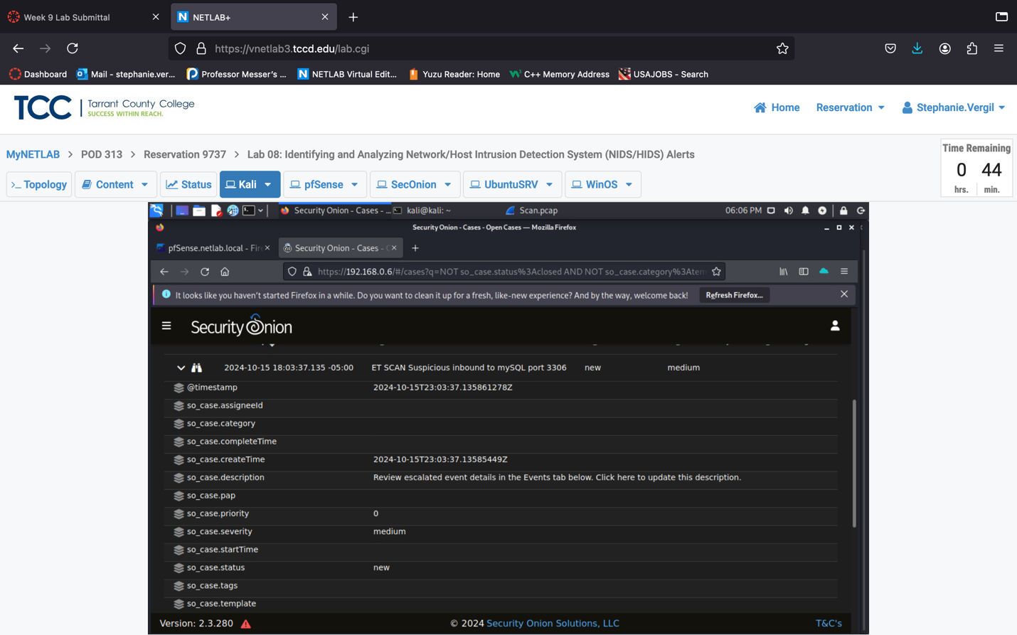

1. Click the View button for the case entry to view more action items.
2. We are going to add some extra notes. Click the Observables button, then click Add a new observable to this case.

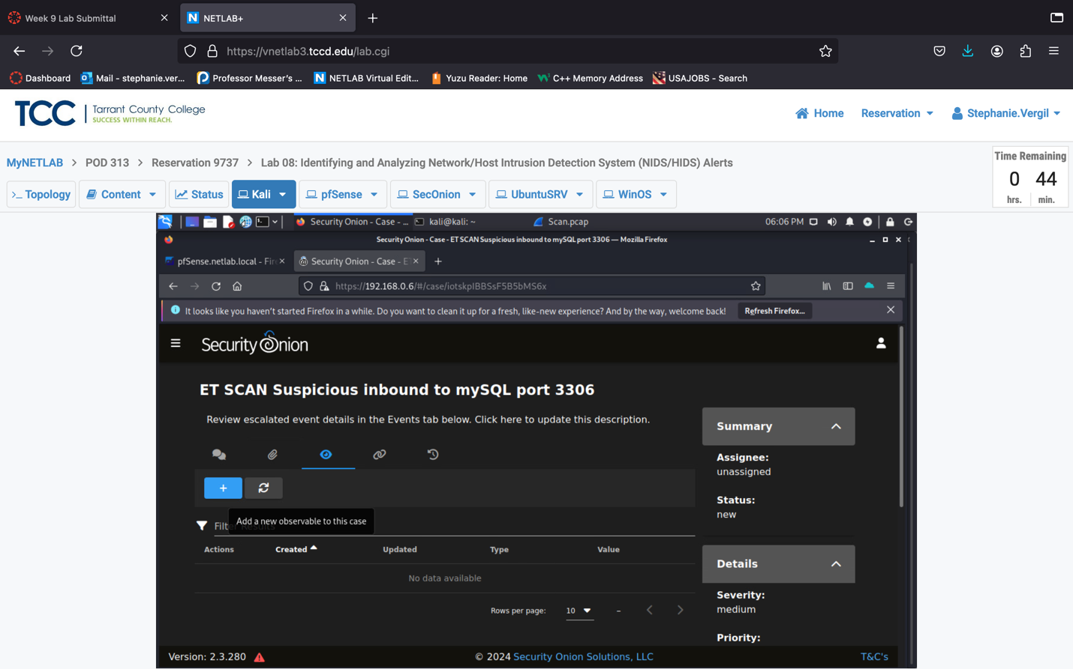

1. In the new window, type the following information, then click the Add button.
2. Type: ip
3. Value: 203.0.113.2
4. Description: If this is not a penetration testing contractor, it could be amalicious external IP address.
5. Traffic Light Protocol: red
6. Tags: nmap

Note: An observable is an extra piece of information we can add to aid the

security team for further investigation.

1. Next step, let’s add some comments. Click on the Comments button.

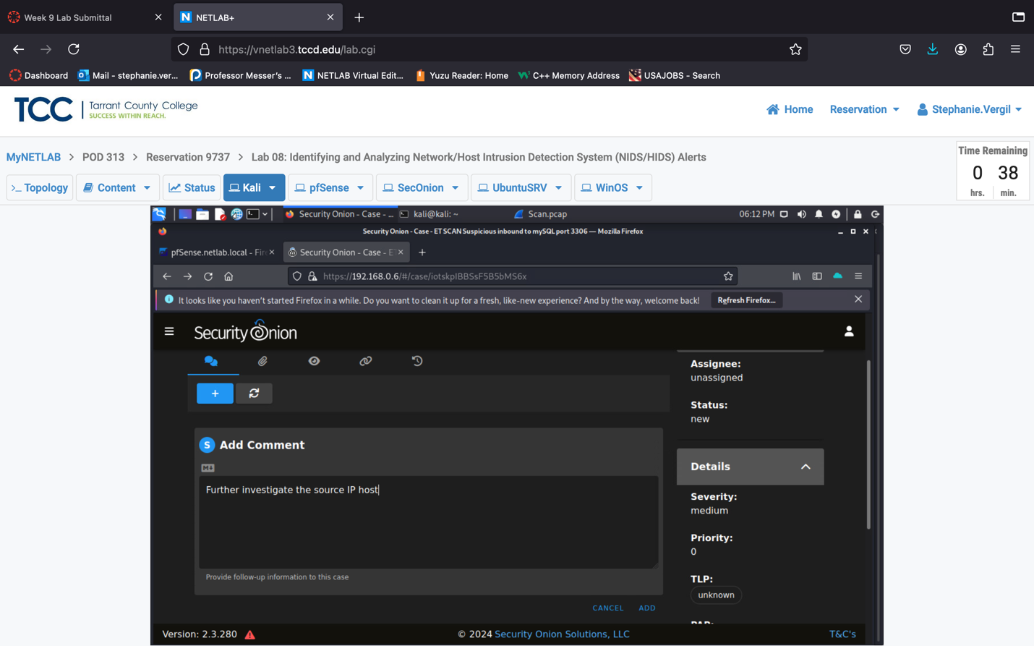

1. Type Further investigate the source IP host, click the Add button to confirm.

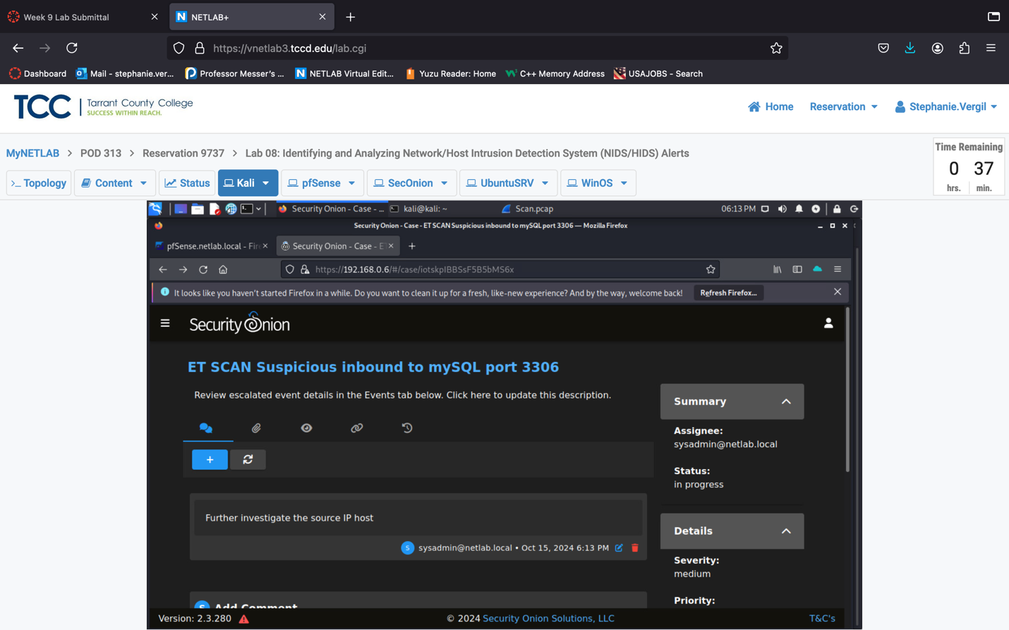

1. In the Summary pane to the right, select sysadmin@netlab.local as the Assignee and in progress as the Status.





1. Leave the window open to continue on with the next task.
   1. **Finish All Tasks and Close a Case**
2. Let’s assume the source IP is a penetration testing contractor. Therefore, we should add it to the log as shown below. Press the Add log button to save.

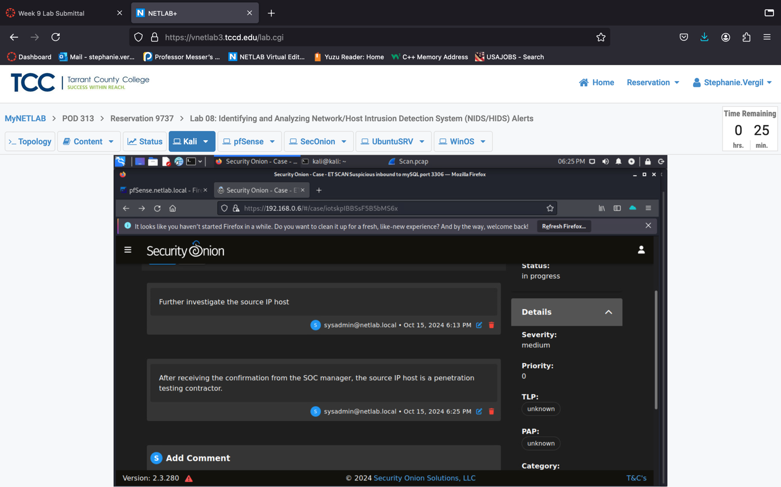



1. Then, we can close this task by selecting closed from the Summary pane.

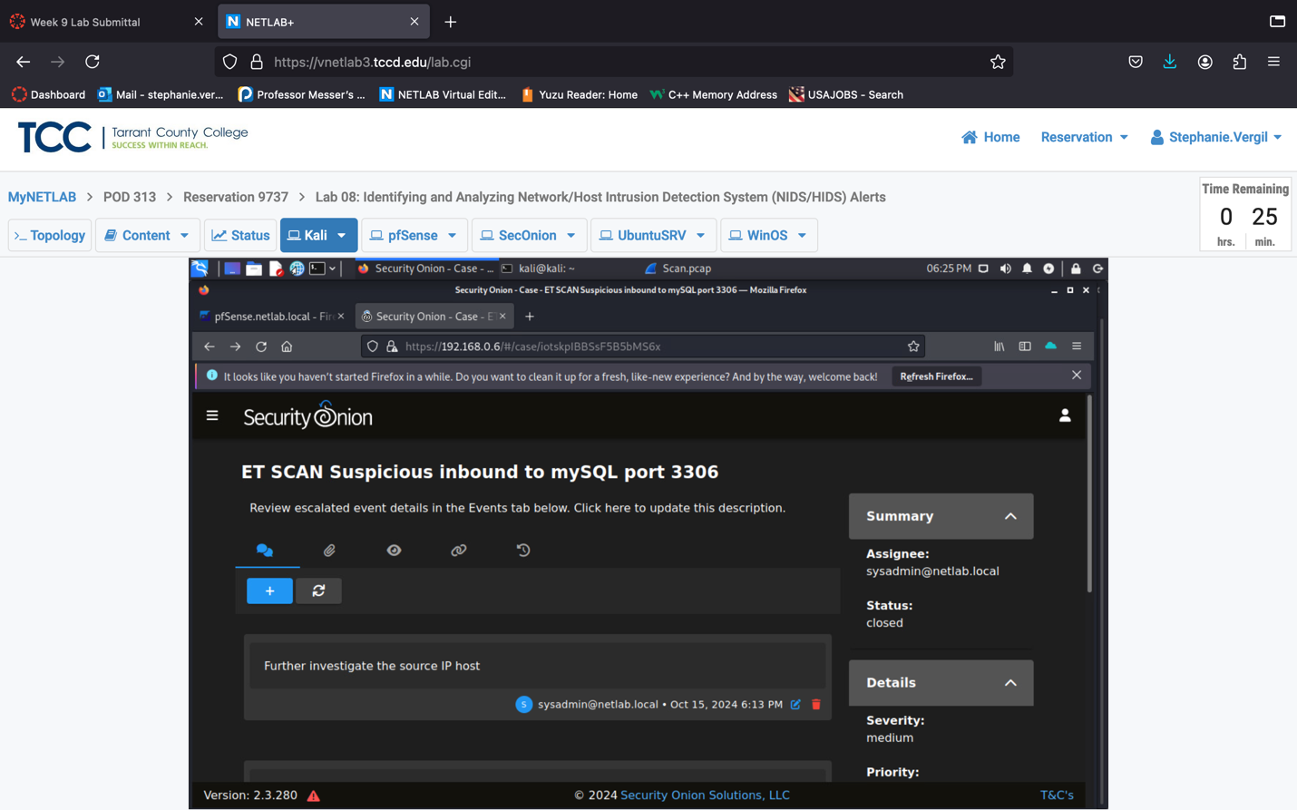



1. The lab is now completed.